***Directions:*** Display a snippet of the code and the output below:

**COP2335: Object-Oriented Programming Lab 6**

1) Write an application that can hold five integers in an array. Display the integers from first to last, and then display the integers from last to first. Save the file as IntArray.

**Snippet of the Code:**

**Snippet of the Output:**

2) Write an application that prompts the user to make a choice for a pizza size—S, M, L, or X—and then displays the price as $6.99, $8.99, $12.50, or $15.00, accordingly. Display an error message if the user enters an invalid pizza size. Save the file as PizzaChoice

**Snippet of the Code:**

**Snippet of the Output:**

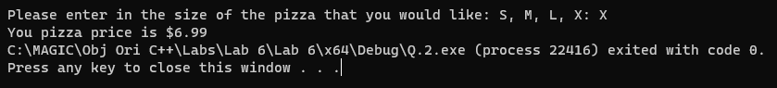

3) Create an application containing an array that stores 20 prices, such as $2.34, $7.89, $1.34, and so on. The application should (1) display the sum of all the prices, (2) display all values less than $5.00, (3) calculate the average of the prices, and (4) display all values that are higher than the calculated average value. Save the file as Prices.

**Snippet of the Code:**

**Snippet of the Output:**

4) Write an application that stores vowels (*a*, *e*, *i*, *o*, and *u*) in an array. Ask the user to enter a character. Then, the program should indicate whether the entered character is a lowercase vowel. Save the file as VowelArray.

**Snippet of the Code:**

**Snippet of the Output:**

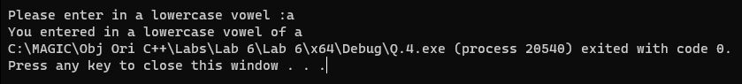

5) Store 20 employee ID numbers in an integer array and 20 corresponding employee last names in a String array. Use dialog boxes to accept an ID number, and display the appropriate last name. Save the application as EmployeeIDArray

**Snippet of the Code:**

**Snippet of the Output:**

